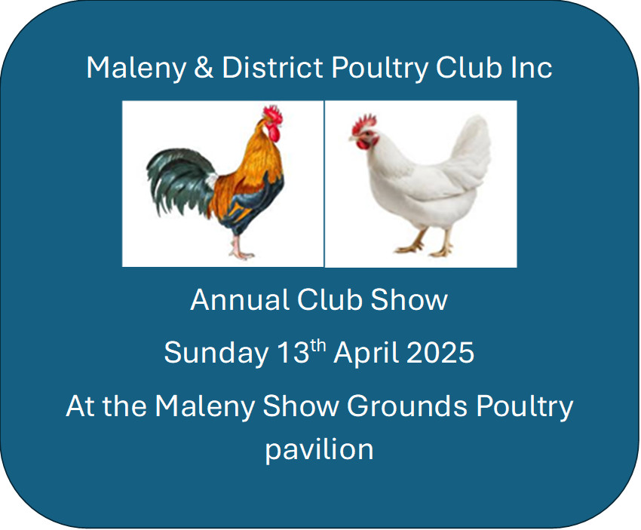
Entries are due
6th April, 2025

President: Cameron Morris 0448 628 835
Secretary: Sue Clifton 0401 705 416
Email: MalenyPC21@gmail.com
Birds to be penned by 8.30am. Judging starts at 9am sharp.

Major Prizes
Grand Champion Bird of Show $400
Res. Champion Bird of Show $200
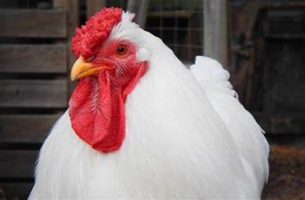

Entry Fees
Member $2.50
Non Member $3
Junior $1.50
Club Membership $10
Junior Club Membership $5

Canteen
Will be open from 7.30am for Breakfast, morning Tea and lunch

Club Regulations:
- All Exhibits must be penned by 8.30am on show day.
- Judging commences promptly at 9 am and the Judge’s decision is final.
- Exhibitors are asked to stay well clear of the Judge whilst judging is in progress.
- In the event of a dispute, it must be lodged through the President.
- Any member or exhibitor of this club who shall be guilty of conduct derogatory to this club may be expelled from exhibiting at this show or any future shows.
- No birds will be released until after the presentation.
- Stewards will supervise penning and unpenning of all birds.
- No entries altered on day of the show.
- Entry fees must accompany entries. All cheques to be made payable to Maleny & District Poultry Club Inc. Entries to be posted to the treasurer.
- The club may exercise its constitutional powers in refusing any entries from any exhibitor should the need arise.
- Diseased or vermin infected birds are NOT to be penned. The club may exercise the authority to ask for removal of such exhibits.
- All birds exhibiting in the show be bonfire property of the exhibitor.
- All care is taken but the club will not be responsible for losses or damage caused to exhibits prior, during or after the show.
- All waterers are supplied by Maleny and District Poultry Club Inc
- All exhibitors should be holders of an FCAQ exhibitor registration certificate.
- The committee whose ruling shall be final will deal with a matter not provided for the rule above.
- In the event of 6 or more entries in AOV or AOC a class will be made.
- Due to limited pens exhibitors can only enter no more than 3 birds per class (i.e., 3 cocks, 3 hens, 3 cockerels and 3 pullets).
- Junior exhibits must be penned by the Junior Exhibitor and a limit of 2 entries per Junior.



Grand Champion Bird of Show $400 & Sash
Reserve Champion Bird of Show $200 & Sash
Champion Soft Feather Large – $50 & Sash
Reserve Champion Soft Feather Large – Bag of Feed & Sash
Runner up Reserve Champion Soft Feather Large - Feeder
Champion Hard Feather Large – $50 & Sash
Reserve Champion Hard Feather Large – Bag of Feed & Sash
Runner up Reserve Champion Hard Feather Large - Feeder
Champion Soft Feather Bantam – $50 & Sash
Reserve Champion Soft Feather Bantam – Bag of Feed & Sash
Runner up Reserve Champion Soft Feather Bantam - Feeder
Champion Hard Feather Bantam – $50 & Sash
Reserve Champion Hard Feather Bantam – Bag of Feed & Sash
Runner up Reserve Champion Hard Feather Bantam – Feeder
Champion Junior – Trophy, bag of feed & Feeder
Reserve Champion Junior – Trophy & Feeder
Vince Carbery Soft Feather Perpetual Award – Trophy
Don Lyons Hard Feather Perpetual Award – Trophy
Bill Morris Memorial Australorp Award – Prize
Breed Champions – Sash and bag of feed
Lucky Exhibitor – bag of feed
Raffles Available on the day

 | SOFT FEATHER LARGE
 | Ancona | Cock | Hen | Cockerel | Pullet |  | Leghorn |  | Cock | Hen | Cockerel | Pullet
 | Red Single Comb | 1 | 2 | 3 | 4 |  | White |  | 137 | 138 | 139 | 140
 | Black Single Comb | 5 | 6 | 7 | 8 |  | Black |  | 141 | 142 | 143 | 144
 | Red Rose Comb | 9 | 10 | 11 | 12 |  | Brown |  | 145 | 146 | 147 | 148
 | Black Rose Comb | 13 | 14 | 15 | 16 |  | AOC |  | 149 | 150 | 151 | 152
 | Araucana |  |  |  |  |  | Minorca
 | White | 17 | 18 | 19 | 20 |  | Black |  | 153 | 154 | 155 | 156
 | AOC | 21 | 22 | 23 | 24 |  | Blue |  | 157 | 158 | 159 | 160
 | Australorp |  |  |  |  |  | AOC |  | 161 | 162 | 163 | 164
 | Black | 25 | 26 | 27 | 28 |  | Orpington
 | Blue | 29 | 30 | 31 | 32 |  | AOC |  | 165 | 166 | 167 | 168
 | White | 33 | 34 | 35 | 36 |  | Plymouth Rock
 | AOC | 37 | 38 | 39 | 40 |  | Dark Barred |  | 169 | 170 | 171 | 172
 | Barnevelder |  |  |  |  |  | Light Barred |  | 173 | 174 | 175 | 176
 | Black | 41 | 42 | 43 | 44 |  | AOC |  | 177 | 178 | 179 | 180
 | Double Laced | 45 | 46 | 47 | 48 |  | Polish
 | Partridge | 49 | 50 | 51 | 52 |  | AOC |  | 181 | 182 | 183 | 184
 | Silver | 53 | 54 | 55 | 56 |  | Rhode Island
 | AOC | 57 | 58 | 59 | 60 |  | Red Single Comb |  | 185 | 186 | 187 | 188
 | Brahama |  |  |  |  |  | White Single Comb |  | 189 | 190 | 191 | 192
 | Gold Partridge | 61 | 62 | 63 | 64 |  | Red Rose Comb |  | 193 | 194 | 195 | 196
 | Blue Partridge | 65 | 66 | 67 | 68 |  | White Rose Comb |  | 197 | 198 | 199 | 200
 | Dark | 69 | 70 | 71 | 72 |  | Silkie
 | Black or Blue | 73 | 74 | 75 | 76 |  | White |  | 201 | 202 | 203 | 204
 | AOC | 77 | 78 | 79 | 80 |  | Black |  | 205 | 206 | 207 | 208
 | Cochin |  |  |  |  |  | AOC |  | 209 | 210 | 211 | 212
 | Buff | 81 | 82 | 83 | 84 |  | Sussex
 | AOC | 85 | 86 | 87 | 88 |  | Coronation |  | 213 | 214 | 215 | 216
 | Croad Langshan |  |  |  |  |  | Light |  | 217 | 218 | 219 | 220
 | Black | 89 | 90 | 91 | 92 |  | AOC |  | 221 | 222 | 223 | 224
 | White | 93 | 94 | 95 | 96 |  | Welsummer
 | AOC | 97 | 98 | 99 | 100 |  | Partridge |  | 225 | 226 | 227 | 228
 | Frizzle |  |  |  |  |  | AOC |  | 229 | 230 | 231 | 232
 | AOC | 101 | 102 | 103 | 104 |  | Wyandotte
 | Hamburg |  |  |  |  |  | Columbian |  | 233 | 234 | 235 | 236
 | Black | 105 | 106 | 107 | 108 |  | White |  | 237 | 238 | 239 | 240
 | Silver Spangled | 109 | 110 | 111 | 112 |  | Gold Laced |  | 241 | 242 | 243 | 244
 | Gold Spangled | 113 | 114 | 115 | 116 |  | Silver Laced |  | 245 | 246 | 247 | 248
 | AOC | 117 | 118 | 119 | 120 |  | AOC |  | 249 | 250 | 251 | 252
 | Langshan |  |  |  |  |  | AOV S/F Large
 | White | 121 | 122 | 123 | 124 |  | AOC |  | 253 | 254 | 255 | 256
 | Black | 125 | 126 | 127 | 128
 | Blue | 129 | 130 | 131 | 132
 | AOC | 133 | 134 | 135 | 136
HARD FEATHER Large |  |  |  |  |  |  |  |  |  |  |  |  |  |  |  | HARD FEATHER LARGE
Australian Game |  | Cock | Hen | Cockerel | Pullet |  | Malay |  | Cock | Hen | Cockerel | Pullet
Black Red |  | 257 | 258 | 259 | 260 |  | Black Red |  | 321 | 322 | 323 | 324
Duckwing |  | 261 | 262 | 263 | 264 |  | Duckwing |  | 325 | 326 | 327 | 328
Pile |  | 265 | 266 | 267 | 268 |  | Pile |  | 329 | 330 | 331 | 332
AOC |  | 269 | 270 | 271 | 272 |  | White |  | 333 | 334 | 335 | 336
Australian Pit |  |  |  |  |  |  | AOC |  | 337 | 338 | 339 | 340
Heavy Clean Face |  | 273 | 274 | 275 | 276 |  | Old English
Light Clean Face |  | 277 | 278 | 279 | 280 |  | Black |  | 341 | 342 | 343 | 344
Heavy Muff |  | 281 | 282 | 283 | 284 |  | Black, Red |  | 345 | 346 | 347 | 348
Light Muff |  | 285 | 286 | 287 | 288 |  | Blue, Red |  | 349 | 350 | 351 | 352
Heavy Hen feather |  | 289 | 290 | 291 | 292 |  | Brown, Red |  | 353 | 354 | 355 | 356
Light Hen feather |  | 293 | 294 | 295 | 296 |  | Pile |  | 357 | 358 | 359 | 360
AOC |  | 297 | 298 | 299 | 300 |  | Spangle |  | 361 | 362 | 363 | 364
Indian |  |  |  |  |  |  | Wheaten Blue Tail |  | 365 | 366 | 367 | 368
Dark |  | 301 | 302 | 303 | 304 |  | AOC |  | 369 | 370 | 371 | 372
Jubilee |  | 305 | 306 | 307 | 308 |  | AOV H/F Large
Blue Laced |  | 309 | 310 | 311 | 312 |  | AOC |  | 373 | 374 | 375 | 376
White |  | 313 | 314 | 315 | 316
AOC |  | 317 | 318 | 319 | 320
HARD FEATHER
BANTAM
Australian Game |  | Cock | Hen | Cockerel | Pullet |  | Malay |  | Cock | Hen | Cockerel | Pullet
Black Red |  | 377 | 378 | 379 | 380 |  | Black, Red |  | 457 | 458 | 459 | 460
Duckwing |  | 381 | 382 | 383 | 384 |  | Duckwing |  | 461 | 462 | 463 | 464
Pile |  | 385 | 386 | 387 | 388 |  | Pile |  | 465 | 466 | 467 | 468
AOC |  | 389 | 390 | 391 | 392 |  | White |  | 469 | 470 | 471 | 472
Australian Pit |  |  |  |  |  |  | AOC
Clean Face |  | 393 | 394 | 395 | 396 |  | Old English
Muff |  | 397 | 398 | 399 | 400 |  | Black Red Light Leg |  | 473 | 474 | 475 | 476
Hen Feather |  | 401 | 402 | 403 | 404 |  | Black Red dark leg |  | 477 | 478 | 479 | 480
Light Muff |  | 405 | 406 | 407 | 408 |  | Blue, Red |  | 481 | 482 | 483 | 484
AOC |  | 409 | 410 | 411 | 412 |  | Duckwing Light leg |  | 485 | 486 | 487 | 488
Indian |  |  |  |  |  |  | Duckwing Dark leg |  | 489 | 490 | 491 | 492
Dark |  | 413 | 414 | 415 | 416 |  | Pile |  | 493 | 494 | 495 | 496
Jubilee |  | 417 | 418 | 419 | 420 |  | Spangle |  | 497 | 498 | 499 | 500
Blue Laced |  | 421 | 422 | 423 | 424 |  | Ginger |  | 501 | 502 | 503 | 504
White |  | 425 | 426 | 427 | 428 |  | AOC |  | 505 | 506 | 507 | 508
AOC |  | 429 | 430 | 431 | 432 |  | AOV H/F Bantam
Modern |  |  |  |  |  |  | AOC |  | 509 | 510 | 511 | 512
Black Red |  | 433 | 434 | 435 | 436
Wheaten |  | 437 | 438 | 439 | 440
Birchen |  | 441 | 442 | 443 | 444
Duckwing |  | 445 | 446 | 447 | 448
Pile |  | 449 | 450 | 451 | 452 |  |  |  | 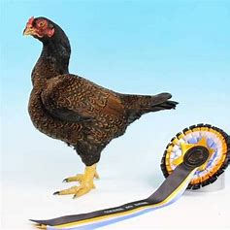
AOC |  | 453 | 454 | 455 | 456

SOFT FEATHER
BANTAM
Australorp | Cock | Hen | Cockerel | Pullet |  | Pekin | Cock | Hen | Cockerel | Pullet
Black | 513 | 514 | 515 | 516 |  | Black | 605 | 606 | 607 | 608
Blue | 517 | 518 | 519 | 520 |  | White | 609 | 610 | 611 | 612
AOC | 521 | 522 | 523 | 524 |  | Buff | 613 | 614 | 615 | 616
Barnevelder |  |  |  |  |  | AOC | 617 | 618 | 619 | 620
AOC | 525 | 526 | 527 | 528 |  | Plymouth Rock
Belgian D’Uccle |  |  |  |  |  | Light Barred | 621 | 622 | 623 | 624
Millefleur | 529 | 530 | 531 | 532 |  | Dark Barred | 625 | 626 | 627 | 628
Mottled AC | 533 | 534 | 535 | 536 |  | AOC | 629 | 630 | 631 | 632
AOC | 537 | 538 | 539 | 540 |  | Polish
Belgian D’anver |  |  |  |  |  | AOC | 633 | 634 | 635 | 636
Millefleur | 541 | 542 | 543 | 544 |  | Rhode Island
Mottled AC | 545 | 546 | 547 | 548 |  | Red Single Comb | 637 | 638 | 639 | 640
AOC | 549 | 550 | 551 | 552 |  | White Single Comb | 641 | 642 | 643 | 644
Frizzle |  |  |  |  |  | Red Rose Comb | 645 | 646 | 647 | 648
AOC | 553 | 554 | 555 | 556 |  | White Rose Comb | 649 | 650 | 651 | 652
Hamburg |  |  |  |  |  | Rosecomb
AOC | 557 | 558 | 559 | 560 |  | Black | 653 | 654 | 655 | 656
Japanese |  |  |  |  |  | White | 657 | 658 | 659 | 660
AOC | 561 | 562 | 563 | 564 |  | AOC | 661 | 662 | 663 | 664
Langshan |  |  |  |  |  | Sussex
Black | 565 | 566 | 567 | 568 |  | Coronation | 665 | 666 | 667 | 668
White | 569 | 570 | 571 | 572 |  | Light | 669 | 670 | 671 | 672
Blue | 573 | 574 | 575 | 576 |  | AOC | 673 | 674 | 675 | 676
AOC | 577 | 578 | 579 | 580 |  | Welsummer
Leghorn |  |  |  |  |  | AOC | 677 | 678 | 679 | 680
White | 581 | 582 | 583 | 584 |  | Wyandotte
AOC | 585 | 586 | 587 | 588 |  | Columbian | 681 | 682 | 683 | 684
Minorca |  |  |  |  |  | White | 685 | 686 | 687 | 688
Black | 589 | 590 | 591 | 592 |  | Gold Laced | 689 | 690 | 691 | 692
Blue | 593 | 594 | 595 | 596 |  | Silver Laced | 693 | 694 | 695 | 696
AOC | 597 | 598 | 599 | 600 |  | AOC | 697 | 698 | 699 | 700
Orpington |  |  |  |  |  | AOV S/F Bantam
AOC | 601 | 602 | 603 | 604 |  | AOC | 701 | 702 | 703 | 704
JUNIORS
Junior Under 11 |  | 705 |  |  |  | Junior Under 15 |  | 706
 |  |  |  | Thank you to our Major Sponsors |  | 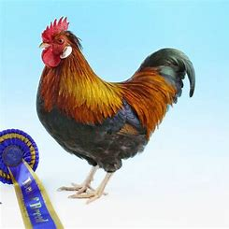
 |  |  |  |  |  |  |  | 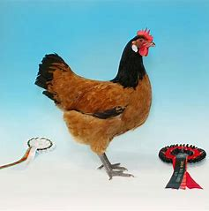
Entries due: 6th April 2025
ENTRY FEES
Member $2.50
Non Member $3
Junior $1.50
Entries to: Cameron Morris
188-216 Fairhill Road
Ninderry Q 4561
Ph 0448 628 835
Email: MalenyPC21@gmail.com

Exhibit | Class Number | No of Entries | Pen Number/s | Total
 | Total Entries |  | Total Amount | $

Exhibitors Name ………………………………………………………………………Phone No………………………………………………..
Address:…………………………………………………………………………..Email ………………………………………………………………
FCAQ No. …………………………………..…………………………………. Age of Junior exhibitor …………………………….…….
Direct Deposit: Maleny & District Poultry Club BSB 124 156 Account 100041498
Please use your name for payment reference and email entry and receipt to MalenyPC21@gmail.com
Cheques payable to: Maleny & District Poultry Club

